

Practices for Secure Software Report

Table of Contents
Document Revision History 3
Client 3
Instructions 3
Developer 3
1. Algorithm Cipher 3
2. Certificate Generation 5
3. Deploy Cipher 6
4. Secure Communications 6
5. Secondary Testing 6
6. Functional Testing 8
7. Summary 9
8. Industry Standard Best Practices 10

Document Revision History

Version | Date | Author | Comments
1.0 | 10/12/2026 | Brock Bieniek

Client



Developer
Brock Bieniek

Algorithm Cipher
I would recommend using the AES-256 encryption to help protect sensitive information that is located in the Artemis Financial application. AES uses a symmetric encryption algorithm that contains a secret key which is used to decrypt and encrypt data. It can support 192-bit, 128-bit, and 256-bit keys and also has become a federal encryption standard since 2001. Bigger keys do provide a lot more resistance when it comes to brute force attacks, although having management over the secure key is so important. AES-256 does provide great security and shows well efficient performance all together.
Cryptographically can be used to secure random number generation which is important for creating many encryption keys. Having known predictable keys can weaken security. Asymmetric encryption implements a pair of private and public keys and also supports secure key access and authentication. I was able to add the SHA-256 hashing, which adds a 256-bit checksum to help better verify data integrity. Unlike any encryption, hashing is a one way method and can’t be decrypted at all. AES-256 is such a good choice when it comes to protecting sensitive information, while SHA-256 can help identify changes toward the given information.

Certificate Generation

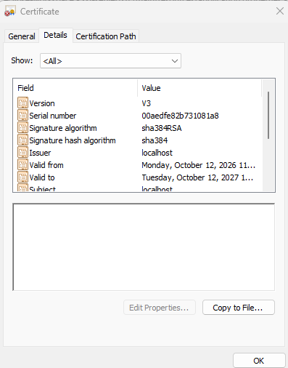
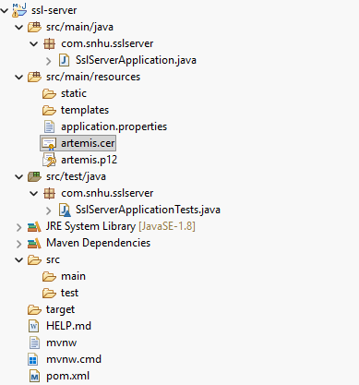

Deploy Cipher

Secure Communications

Secondary Testing

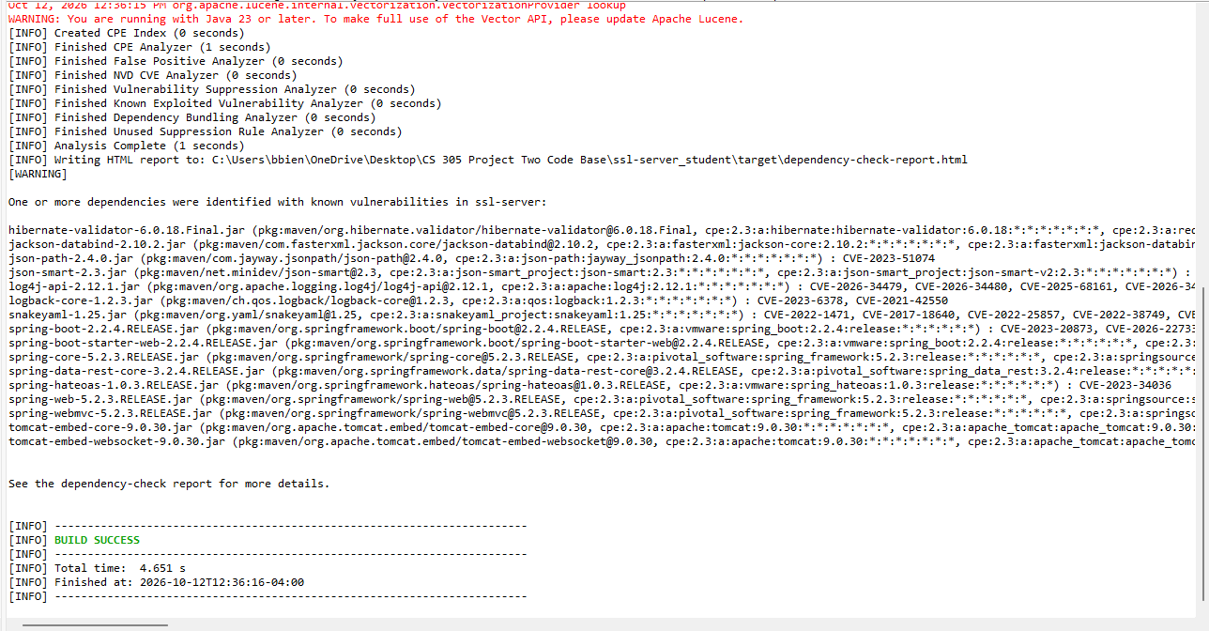
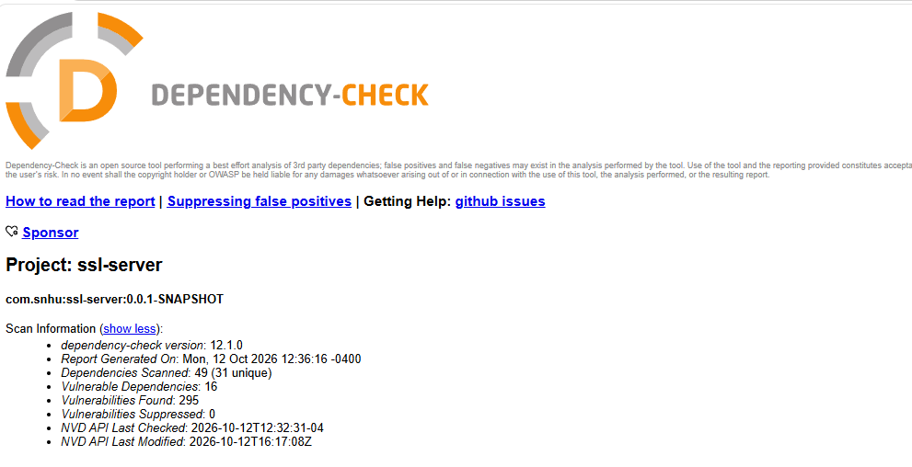
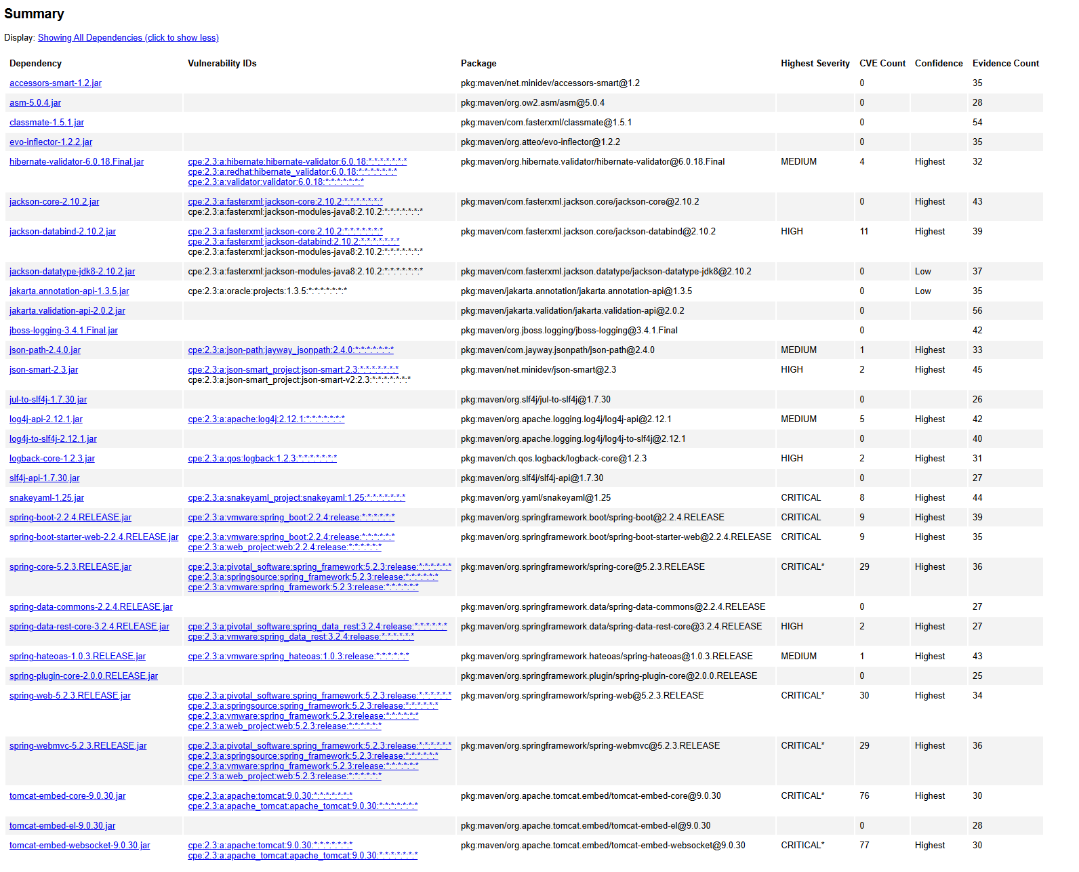

Functional Testing
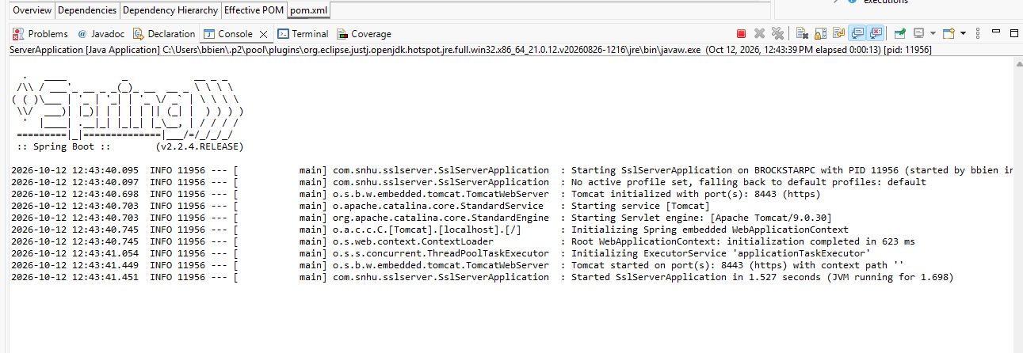
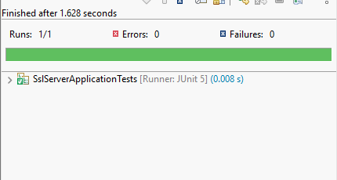

Summary

I was able to improve the security in the Artemis Financial application by adding the SHA-256 hashing and enabling a HTTPS communication method. It was done using a self-signed certificate. I had also created a 3072-bit RSA certificate using the Java Keytool and then configured the application to use a certain PKCS12 keystore. These important changes had added more layers of security by encrypting communication and supporting data integrity during local testing sessions.
I was able to follow the vulnerability assessment process by reviewing the application’s code within, identifying many security weaknesses, implementing new changes at once, and testing the results once done. I was able to check the HTTPS configuration, SHA-256 implementation, and handling of the password for any possible logical problems or syntax errors. I ran the application in Eclipse and performed each functional test to confirm that my code was working correctly. The application had properly displayed the SHA-256 checksum through the HTTPS, and its one JUnit test had passed with no errors.
I was able to use the OWASP Dependency Check to help locate 49 dependencies and also found 295 reported vulnerabilities across 16 different dependencies. This unique find has shown many outdated libraries which still require an update. This project has greatly shown me how secure communication, hashing, reviewing code manually, functional testing, and dependency scanning all work together to improve the application's security protocols.

Industry Standard Best Practices
I was able to apply many industry standard practices by adding the SHA-256 hashing to help support data integrity and enabling a secure HTTPS to help encrypt communication between the browser and the application. I had created a self signed certificate using the Java Keytool and then configured a PKCS12 keystore right after. An environmental variable was used to keep the keystore password out of the main application properties file.
I followed many secure coding practices such reviewing my code constantly, testing for functionality, and using the OWASP Dependency Check to help identify any known vulnerabilities within many third-party libraries. The scan had shown many outdated dependencies, including Tomcat and Spring Boot components, that contain critical security findings within. These vulnerabilities still have to be addressed through many dependency updates and more constant tests.
When it comes to a production environment, I would need to use a certificate that was issued by a trusted certificate authority, securely manage each encryption key, update every single vulnerable dependency, and perform constant code reviews while providing security scans as well. These methods will help reduce many security risks from occurring, protect tons of sensitive data, and improving overall efficiency when it comes to being a reliable application.

